**ASSIGNMENT 8**

**QUESTION 1**

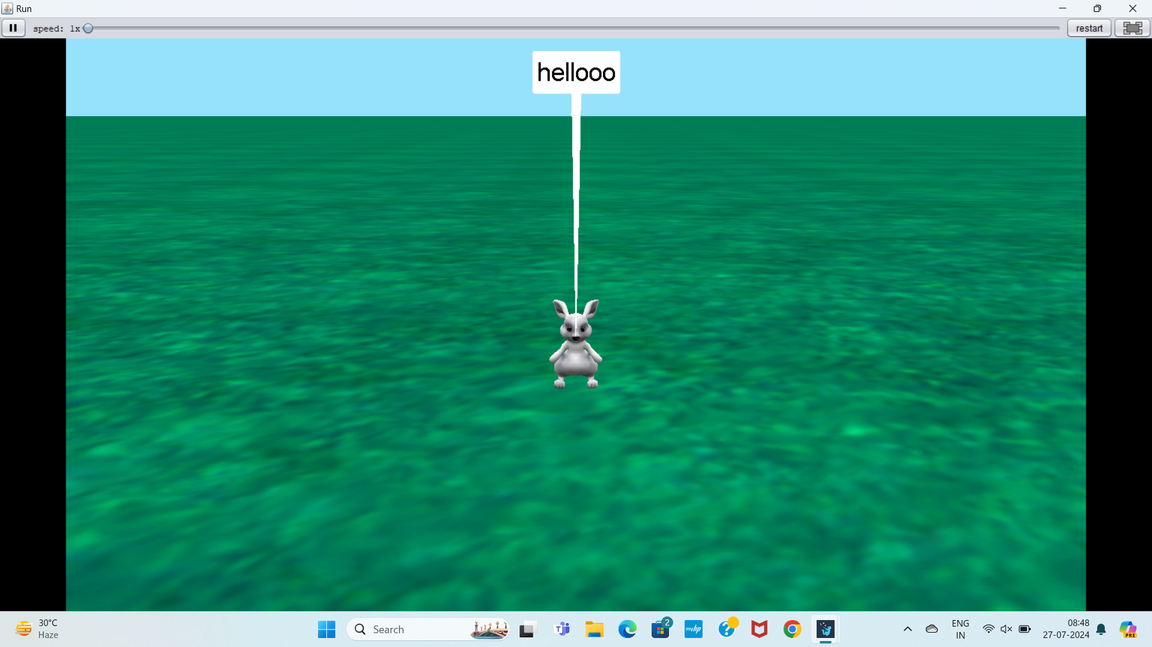

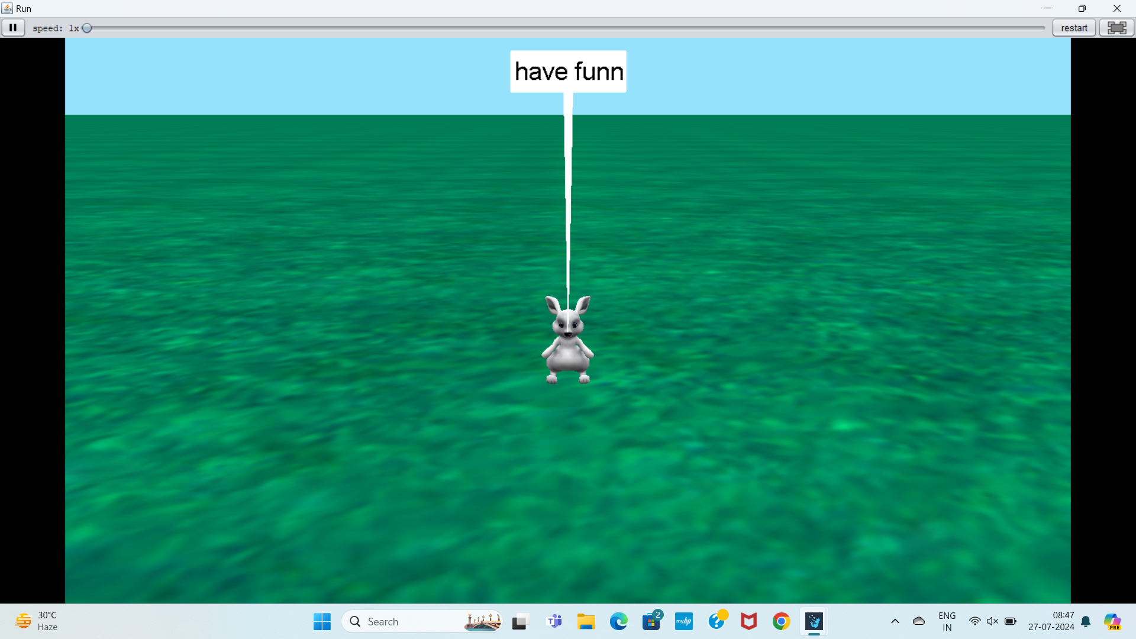

**QUESTION 2**

